Title
DLL Surface Scatter_C++_Non-Sequential_Lambertian Depolarizer

Author
Neil Griffin - Technology Partnership Plc
Michael Cheng - Zemax

Brief Description
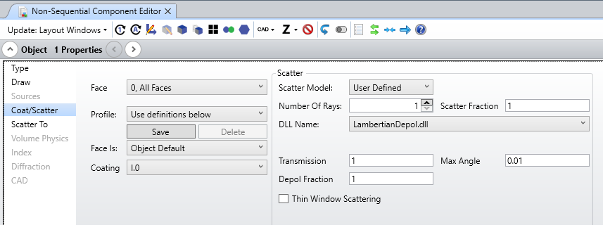

Overview
This Surface Scatter DLL models a Lambertian scattering and contains a depolarization fraction parameter to depolarize part of the scattered rays. That DLL is a good example to demonstrate how to control the electric field and how to implement Importance Sampling. The code is based on "{Zemax}\DLL\SurfaceScatter\Lambertian.DLL".

Plugin Type
DLL Surface Scatter

Language
C++

Updates
Date | Version | OpticStudio version | Comment
20190113 | 1.0 | 19.8 | Creation

Instructions

Installation
To install the DLL, copy the LambertianDepol.dll file under {Zemax}\DLL\SurfaceScatter.
Update the File Listings in the Editor toolbar to view the newly installed DLL.
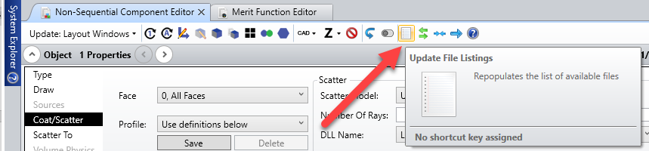

How to use
To use the DLL, open the attached non-sequential file. It contains a Source Ray with polarized light (Jx=0, Jy=1). The Source sends light on a rectangle. The rectangle is scattering light using the LambertianDepol.dll. Scattered light is then recorded on two Detector Rectangle.
Detector 4 has the Polarization flag set to 1, which means that it only considers the component of the rays polarized along the local X direction.
Detector 5 records all the light.
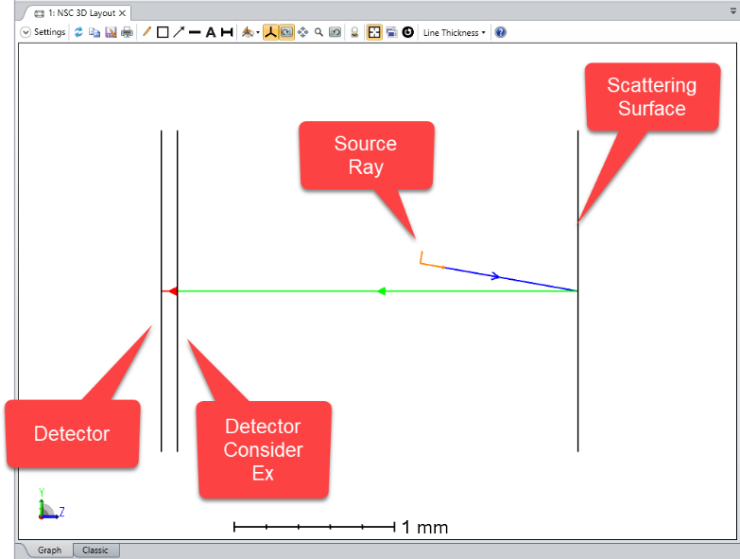

Open the properties of Object 1 and select Coat/Scatter:
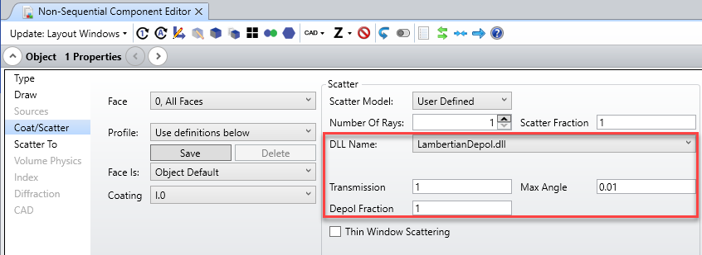
The Transmission and Max Angle parameters are similar to "{Zemax}\DLL\SurfaceScatter\Lambertian.DLL".
Depol Fraction: is the fraction of light which is going to be unpolarized (the electric field will be set randomly).

In the Universal Plot, the Detector Rectangle that only considers Ex is rotated around its z-axis. We can see light is depolarized. Note the there are some ripples because only 100 analysis rays are traced so the beam is still a bit polarized. With 10000 rays, the plot is flat meaning light is totally unpolarized.
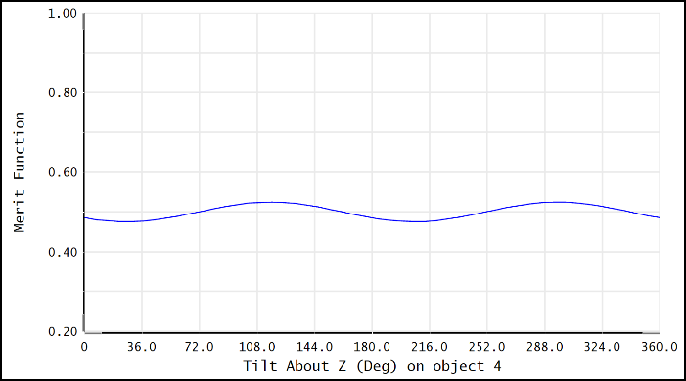

If the depolarization factor is set to 0, we can see the result below.
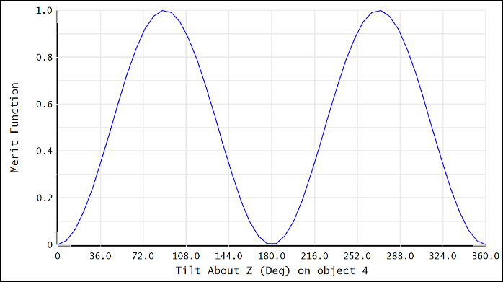

If we turn on Importance Sampling, it’s similar as shown below. Again, more rays need to be traced to check the depolarization.
Note that the energy for each ray is very small. The setting of Minimum Relative Energy Per Ray might need to be changed for that test.
When Importance Sampling is on, the software assumes that the surface scatters light in a hemisphere (it ignores the max angle), and only keeps the fraction defined in the Importance Sampling settings. So the total flux recorded will be adjusted to reflect this.
